**INTERNSHIP PROJECT REPORT**

**ON**

**“SUPPLY CHAIN MANAGEMENT DATA ANALYSIS”**

**SUBMITTED BY:**

**PRAYAS SAMAL**

**EXECUTIVE SUMMARY**

With a focus on quality control, logistical efficiency, and profitability, this research offers a data-driven perspective of supply chain operations.  
  
Important Product and Financial Insights: The skincare product category leads in sales volume and produces the highest overall revenue. Nonetheless, the category with the highest average net profit per product is cosmetics, indicating a higher margin structure that calls for additional optimization. In terms of production volume, Supplier 1 is among the top two suppliers and contributes the most to the overall net profit.

Operational Efficiency (Lead Times): Considerable differences in lead times between sites were found. Mumbai, thanks to its effective manufacturing, maintains the shortest average lead time overall (around 14.3 days). On the other hand, because of their longer manufacturing and shipping schedules, Kolkata and Chennai have the largest average overall lead times (more than 17 days). These areas are important bottlenecks that need to be reviewed right now.

Quality and Cost Control: Inspection results analysis demonstrates a clear correlation between defects and quality problems: products with a "Fail" inspection have the highest average defect rate (2.57%). Additionally, it has been established that, on average, air transportation is the most costly shipping method. The information shows a somewhat negative relationship between production lead time and product pricing.

Suggestion: To optimize the high per-unit profitability of the Cosmetics product line, concentrate on supply chain optimization in high-lead-time regions such as Chennai and Kolkata and establish focused tactics.

**TABLE OF CONTENTS**

|  |  |  |
| --- | --- | --- |
| **SERIAL NO** | **PARTICULARS** | **PAGE NO** |
| 1. | EXECUTIVE SUMMARY | 2 |
| 2. | OBJECTIVES | 4 |
| 3. | DATA ANALYSIS | 5-17 |
| 4. | CONCLUSION | 18 |

**OBJECTIVES**

The following major goals are intended to be accomplished by this study, which is based on the thorough supply chain data analysis:

Analyze Product Profitability and Performance: To determine the highest-margin product category (Cosmetics) and the highest-revenue contributor (Skincare), compute the Net Profit for each product type, and compare total revenue and sales volume.

Benchmark Supplier Financial Contribution: To collect and rank suppliers based on their entire contribution to Net Profit and Production Volume, thereby emphasizing essential vendor relationships for strategic management.

Determine and Measure Bottlenecks in Logistics: To determine which operating sites (such as Chennai and Kolkata) have the longest lead times and need efficiency improvements by breaking down the total lead time (manufacturing lead time plus shipping time) across all of them.

Evaluate the effectiveness of quality control by calculating the correlation between average defect rates and product inspection results (pass, fail, or pending) in order to measure the quality risk related to various production outcomes and confirm the influence of current quality procedures.

Examine Transportation Cost Efficiency: To help guide decisions about cost-effective shipping tactics, compare the average shipping costs for different modes of transportation (air, rail, road, and sea).

**DATA ANALYSIS**

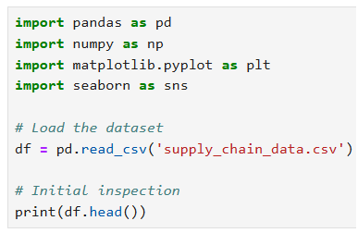

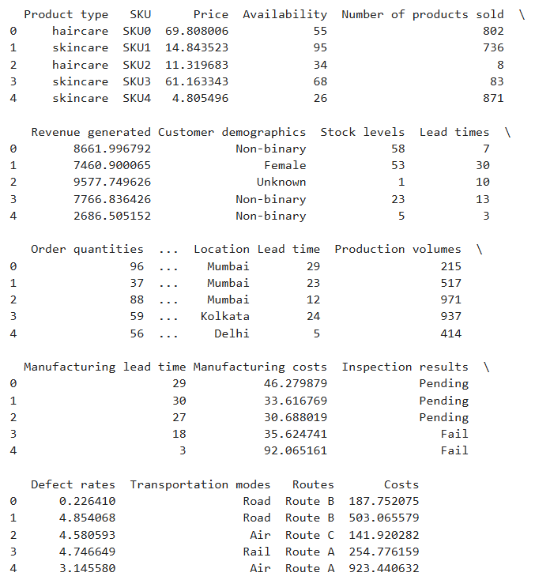

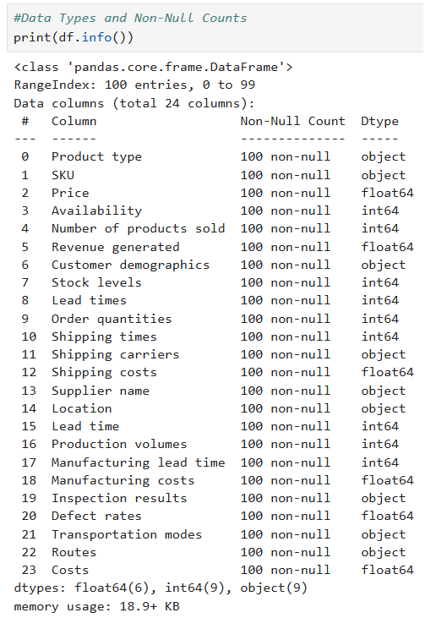

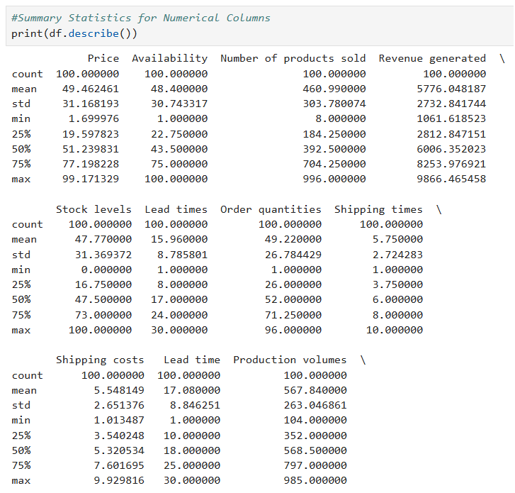

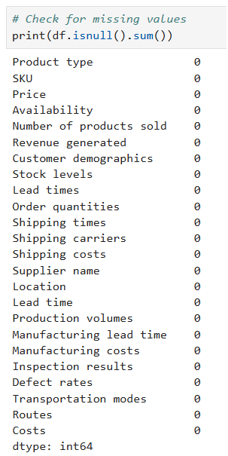

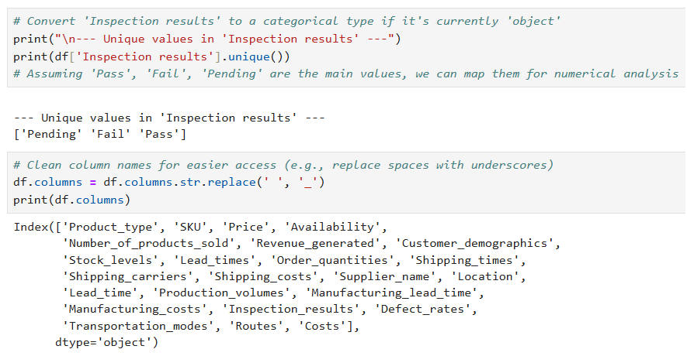

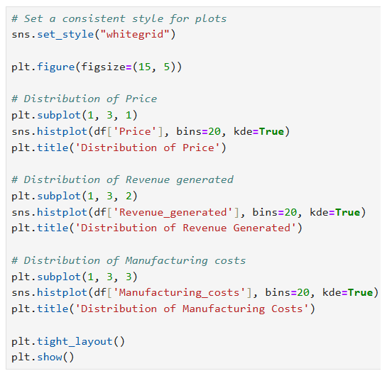

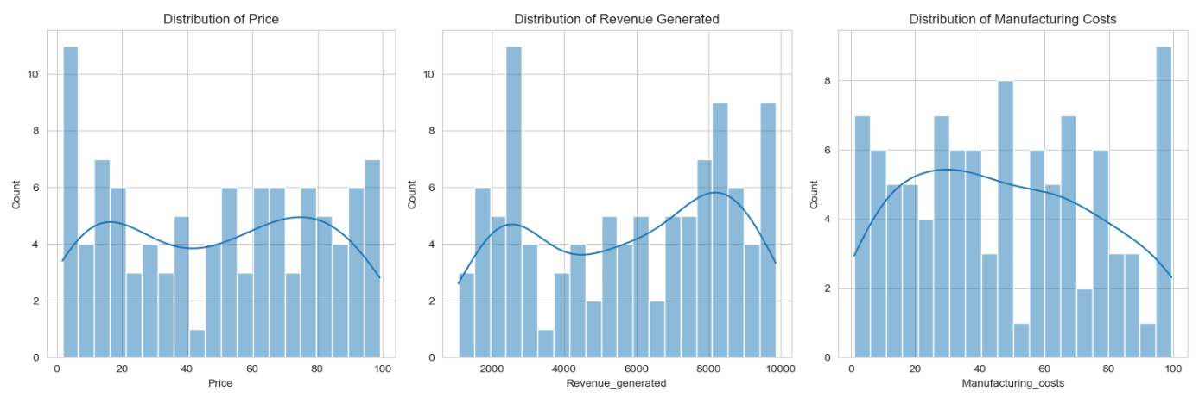

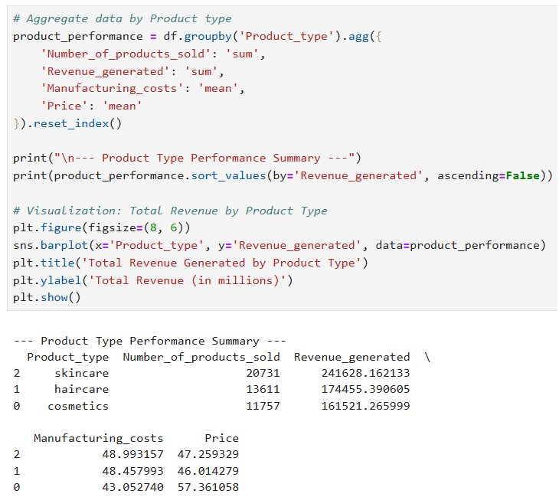

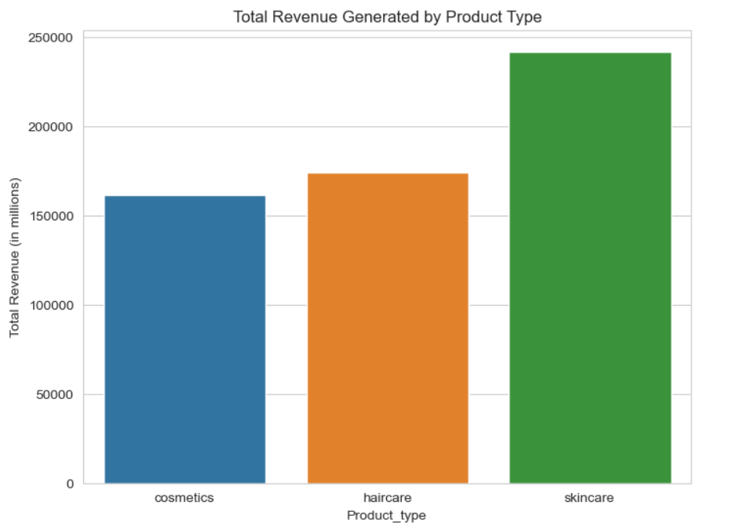

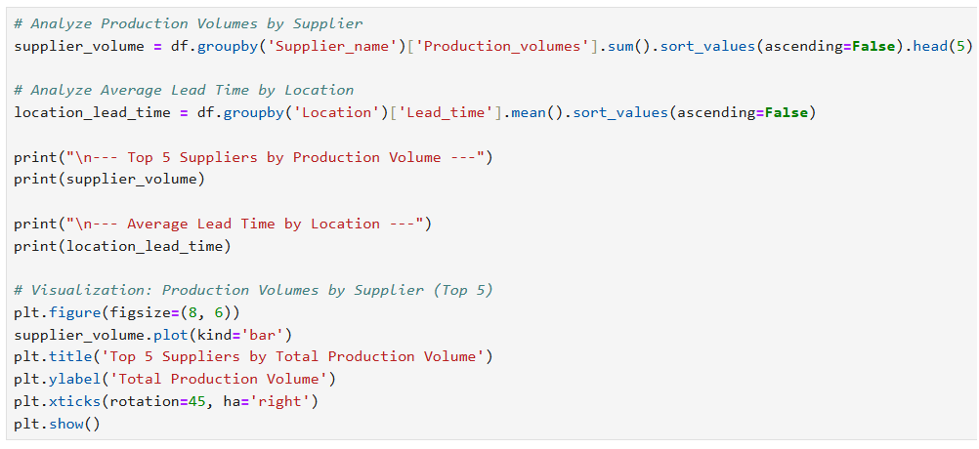

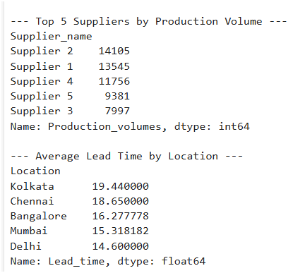

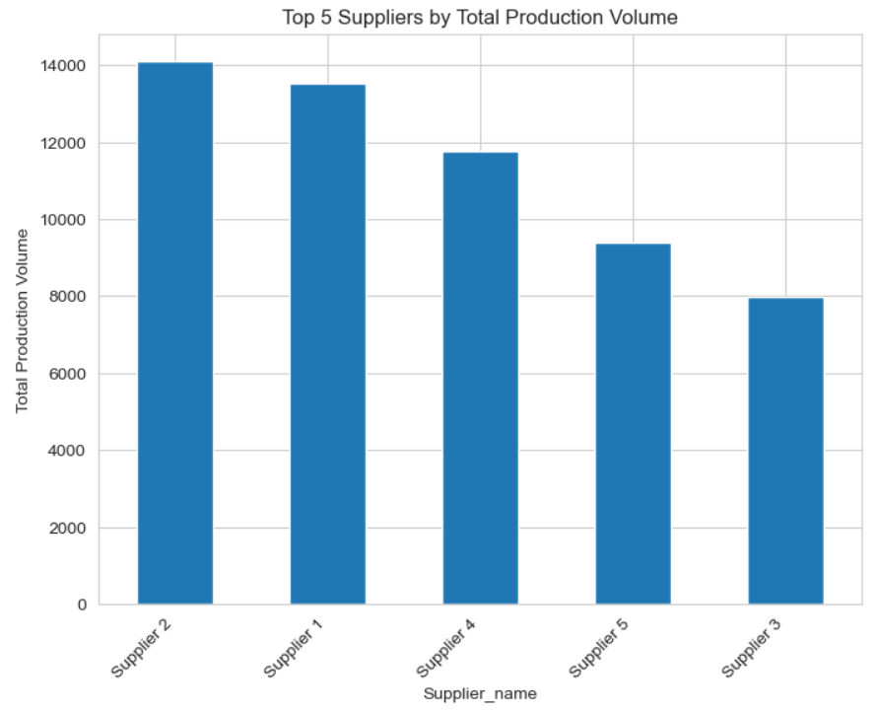

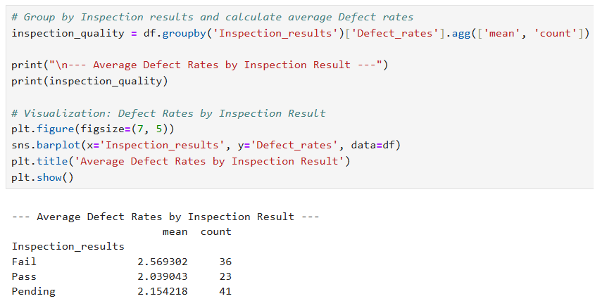

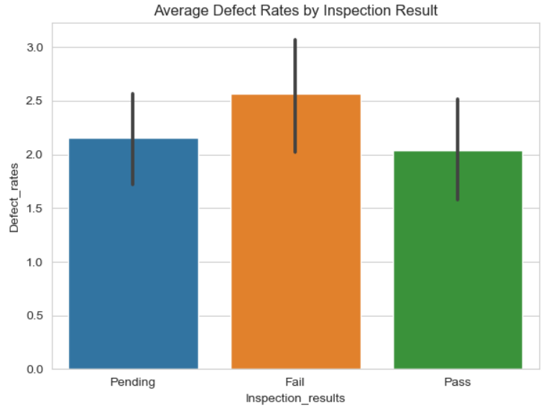

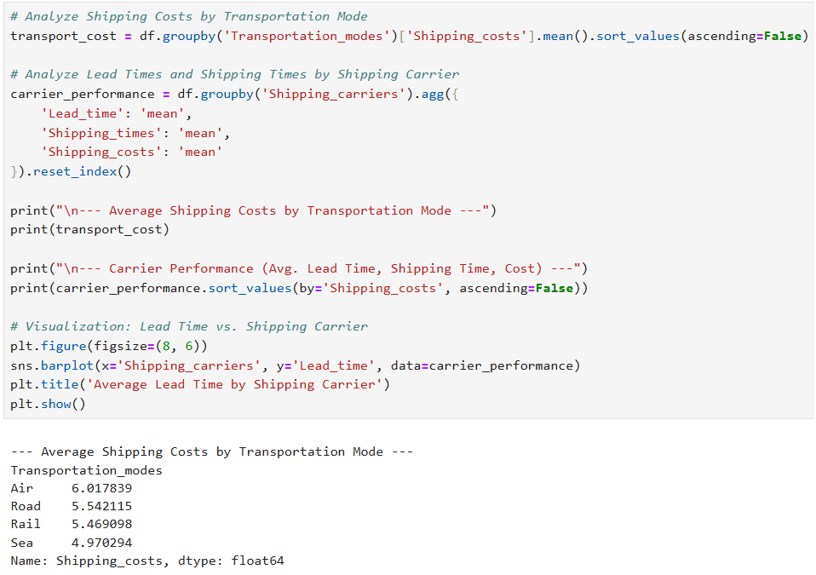

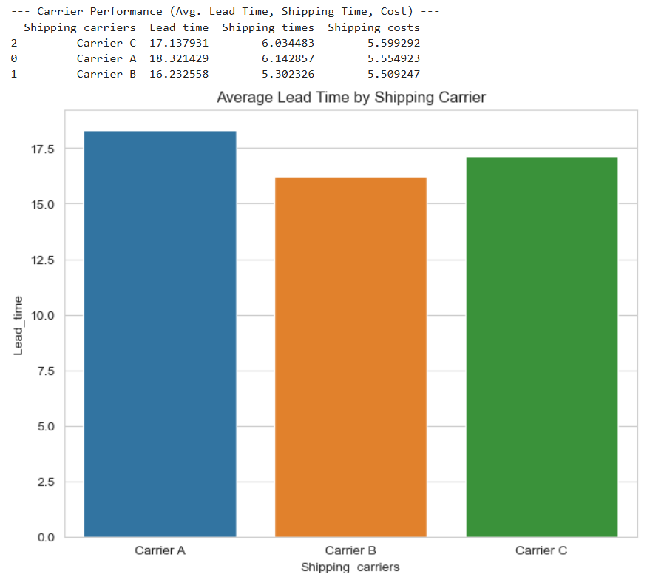

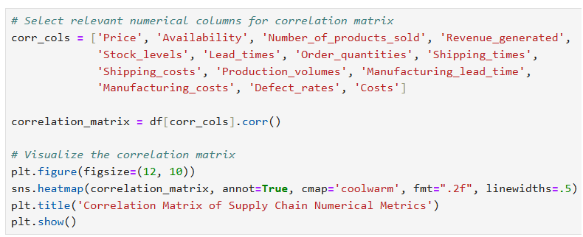

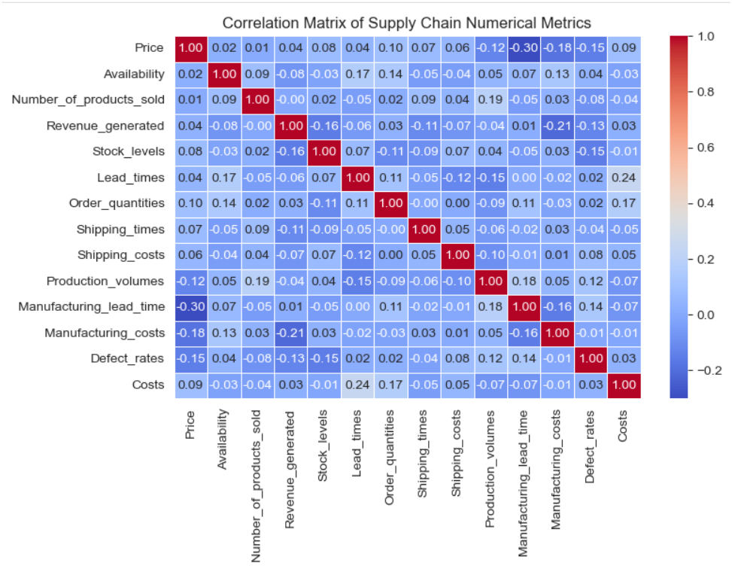

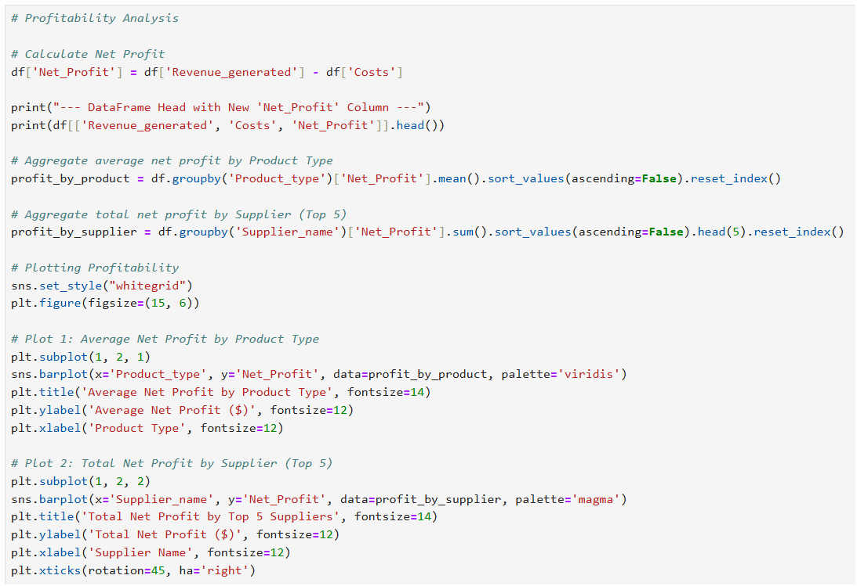

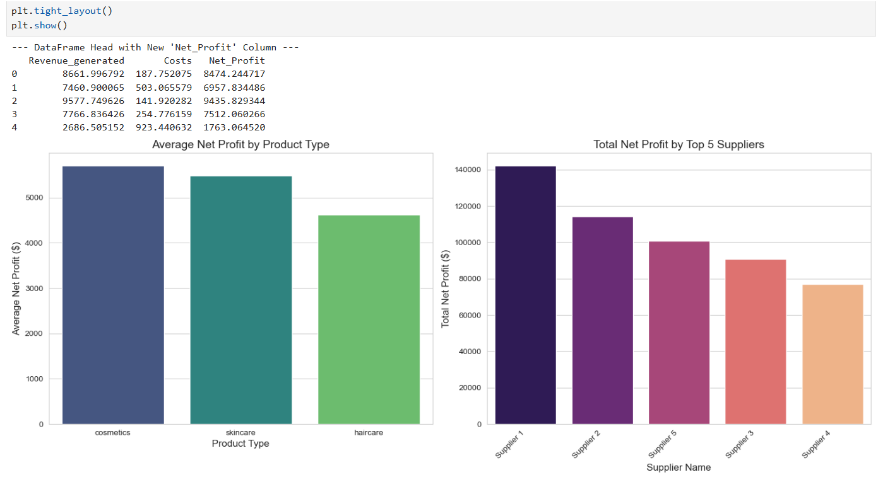

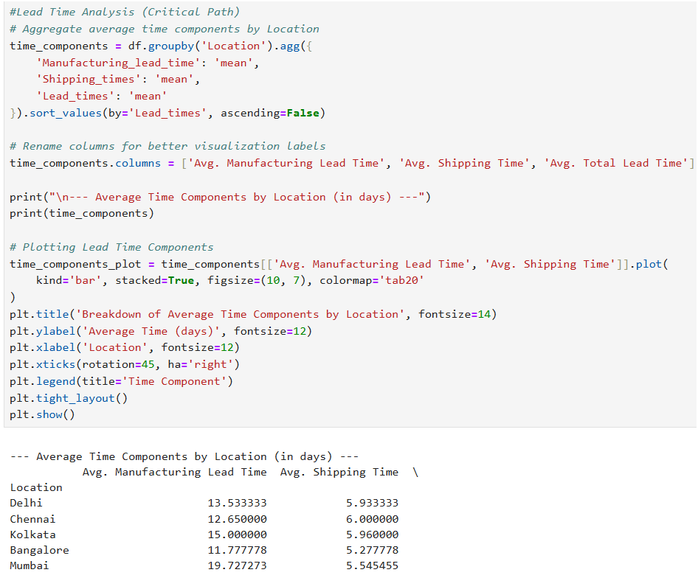

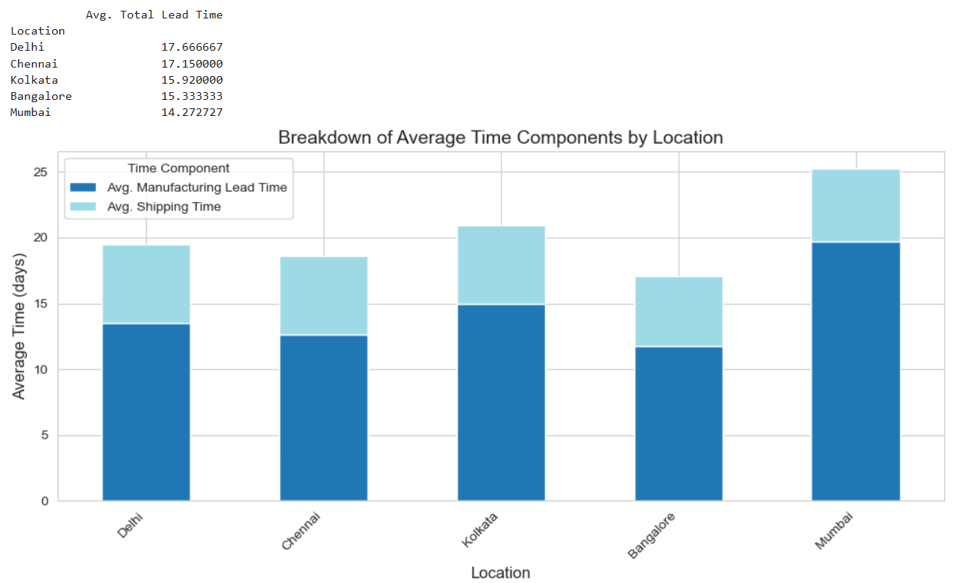

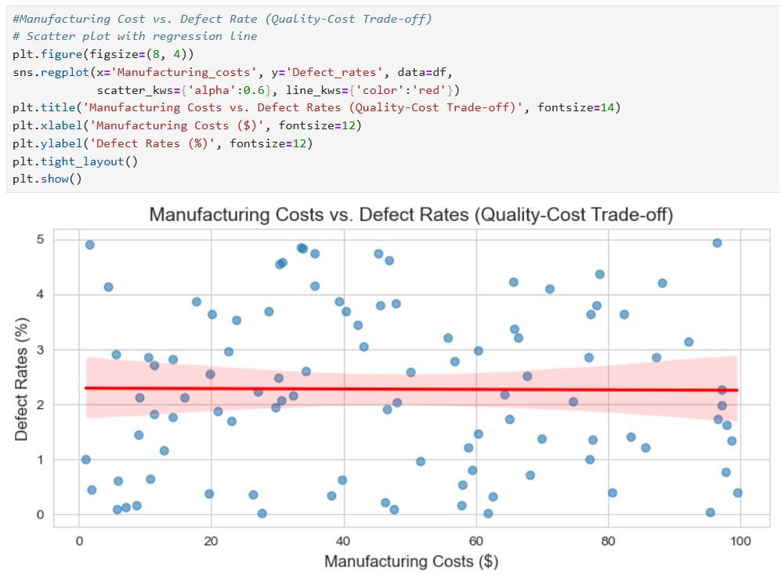

**CONCLUSION**

The comprehensive analysis of the supply chain data successfully achieved the project objectives, providing clear insight into product performance, operational bottlenecks, and quality control effectiveness.

The data confirms a strategic duality in product performance: while the Skincare product line drives the highest overall Revenue Generated, the Cosmetics line maintains the highest Average Net Profit per unit. This suggests that future strategies should focus not just on volume, but on maximizing the margin potential of Cosmetics.

Significant operational inefficiencies in the conversion cycle were identified by the investigation. Due to their lengthy manufacturing and delivery times, Kolkata and Chennai are clearly the most time-consuming sites in the regional Lead Time analysis. In order to lower working capital and shorten time-to-market, these areas are the most important goals for process improvement projects. Regarding quality, the data shows that products that fail inspection have a higher average Defect Rate (2.57%), which is quantifiable and supports the need for rigorous quality gate enforcement.

**Suggestions**

These results suggest the following courses of action:

Strategic Profit Maximization: To identify the characteristics that contribute to the Cosmetics line's strong profitability and reproduce those elements in other product categories, start a thorough cost-to-serve analysis.

Focus on Lead Time Reduction: Send an optimization task force to Chennai and Kolkata to examine and optimize shipping and manufacturing procedures in an effort to match their overall lead times with the Mumbai location's more effective metrics.

Quality Process Audit: Examine how products marked as "Pending" inspection are handled right away, since they make up the majority of units and have a high defect rate (2.15%), which might be decreased with quicker resolution.